Sturgeon School Division

Interschool Sports

Parent/Student

Handbook

Table of Contents
Philosophy
Preamble
Team Selection
General Code of Conduct
Code of Conduct: Players
Code of Conduct: Parents
Code of Conduct: Coaches
Breaches of the Code of Conduct 9
Breaches by Players
Breaches by Parents
Breaches by Coaches
Sturgeon School Division Interschool Sports Player/Parent
Student Athlete
Parent/Guardian of the Athlete

Sturgeon Interschool Sports

Philosophy

Sturgeon School Division believes the interschool sports program promotes positive, caring, healthy schools. Sturgeon School Division also believes adults who work with students in the interschool sports program must present a positive role model for the students to emulate. For the program to be positive and healthy, cooperation and consistent communication must be maintained between parents, coaches, student athletes, and school administration. The program fosters school spirit in our school through peer pride and allegiance. Student athletes benefit from learning how to work together as a team by cooperating - the greater the cooperation, the greater the competitive ability. Parents benefit from knowing their children are involved in a program which is positive, develops self-esteem and improves their children’s social, mental and physical capacities. The Coach benefits from the added rapport and respect earned, not only from the team, but also from the total student population and the community at large. Administrators are assisted in developing a caring environment for all students. Sturgeon School Division believes all stakeholders benefit from the interschool sports program.

Each season will begin with a Coach’s meeting, led by the ISC re and Admin at the respective school.

Preamble

Sturgeon School Division provides three levels of athletic programming. At level one, each student is involved in a mandatory curriculum of physical education as prescribed by Alberta Education. At level two, each school provides an intramural program for those students who wish to participate and develop their skills. At level three, the Sturgeon Interschool Sports Program exists to provide a variety of experiences to assist in the development of advanced athletic skills and attitudes in participating students. Participation in this program is a privilege, not a right. The program at each school strives to be one of athletic excellence.

This document contains the parameters of expected conduct for participating athletes, parents, and coaches.

Team Selection

The following are general guidelines and by no means are an exhaustive list:

- All Junior High students are eligible and encouraged to try out for the school team.

- Students shall be selected by the coach to represent the school.

- The makeup of the team shall be one which increases the completive level of the players for the present season, as well as giving younger team members an opportunity to develop their skills for the following years.

- Players will be chosen and game time will be awarded, based upon the following factors:
  - Work Ethic – Players are expected to give maximum effort at practices, games, and tournaments.

  - Attitude – Players must cooperate with coaches, teammates and officials. The athletes are expected to represent the school in a positive manner at all times.

  - Commitment – Players must be committed to their school, academics, athletics, and teammates. Team players are defined as players willing to sacrifice personal goals for the accomplishment of team goals.

  - Ability – Players should display their highest level of skill at all times.

- The final decision on selection of team members and playing time shall rest with the coach(es).

  - Junior teams, for the most part, will be developmental programs based around skill development and equitable playing time. Senior teams will be based on fair playing time, not equal and the program will be based on a competitive premise.

  - Junior teams will be comprised of grade 7 and 8 students only and all grade levels (7, 8, 9) will be allowed to compete for the Senior teams.

General Code of Conduct

General Code of Conduct
All participants involved in the Sturgeon Interschool Sports Program will conduct themselves in a manner that promotes the good will and positive spirit of athletics. Participants will conduct themselves with the highest standard of courtesy, integrity, and good sportsmanship.

- All members and participants shall respect other coaches, players, team members, fans, spectators, officials, volunteers, parents, team officials, and school division employees. Any inappropriate conduct, threats, harassment, or abuse (verbal or physical) directed towards coaches, players, team members, fans, spectators, officials, volunteers, parents, team officials, and school division employees will not be tolerated.

- All coaches, members, fans, and participants of athletic events shall behave in a positive and supportive manner.

- All players, fans, and participants are required to abide by the bylaws, rules and regulations set forth by the Sturgeon Interschool Sports Committee, and their behavior is expected to mirror the spirit of the bylaws, rules and regulations, and this code.

- Violation by any member, fan or participant of this document and the codes of conduct contained within may result in an immediate and indefinite suspension or expulsion from interschool athletic activities; games, practices, tournaments, and special events for the family (including the player) or family member involved.

Code of Conduct: Players

I realize that participation on a school team is a privilege, and not a right, and because of this, I will adhere to the following code of conduct:

I will:
- Demonstrate qualities of integrity, courtesy, and good sportsmanship at all times:

  - I will play by the rules and in the spirit of the game.

  - I will control my temper.

  - I will respect my opponents, coaches, officials, fans, etc.

  - I will always strive to give my best on and off the field of play.

  - I will have a positive outlook regardless of the circumstances.

  - I will be a team player who supports the actions, decisions, and the outcomes of my coaches and my teammates.

- Demonstrate a commitment to coaches and teammates by:

  - I will attend and be on time for every practice and game. I will give 100% effort 100% of the time.

  - I will strive to improve in all skills involved in my activity and reach for the highest level of mastery. (Mastery frequently indicates and involves extra effort, and the reward is playing time.)

  - I will communicate to my coach and teammates any information which will affect my participation and commitment in team activities.

- Coaches are volunteers and are committed to giving their best for each player and the team:

  - I will do the same in return for my coaches.

- All players will represent their coaches, teammates, and schools through solid school citizenship.
  - I will strive to achieve the best academic standing possible.
  - I will conduct myself in a manner that strongly represents my school in all activities.
  - I will follow all codes of conduct within my school and school division.

Code of Conduct: Parents

I realize that participation on a school team is a privilege, and not a right, and because of this, I will conduct myself according to the following Code of Conduct:

I will:

- Respect and show appreciation for the volunteers who give their time to provide sporting activities for my child.

- Handle disputes between myself and team officials with dignity and through proper team channels. The first person I will discuss the problem privately with is the coach. In the rare event a solution cannot be realized in communication with the coach(es), I will seek the assistance of the school’s administration. Gossip, infighting, grudges, etc. are not credible examples of mature behavior to the children.

- Handle disappointment, whether it occurs through disputes, my child’s skill, the officials and their decisions, placement on a team, etc., with dignity, maturity, and common sense. No one wins all of their arguments, plays their best all of the time, or agrees with every decision.

- Remember that my child plays sports for his or her enjoyment, not mine.

- Encourage my child to play by the rules, and to resolve conflicts without resorting to hostility or aggressive behavior.

- Teach my child that “doing one’s best” is as important as winning.

- Be positive and supportive in my comments to my child during competition.

- Be a fan, not a fanatic.

- Support all of the guidelines contained in this handbook, including the coach’s selection of the team and the playing time.

Code of Conduct: Coaches

All coaches will embrace the philosophy that the game is a game of enjoyment. It is played, not only in the pursuit of excellence, but to promote a healthy lifestyle in the social, mental, and physical development of the student. All coaches are to lead by example, and should therefore follow the same expectations of conduct as the players.

All coaches will focus on maintaining a high level of integrity and good sportsmanship as leader of their team.

I will:

- Follow the rules of the game which are to be regarded as mutual agreements. The spirit or letter of which no one should try to evade or break. No advantages, except those of superior skills, are to be sought over others.

- Regard and treat all officials and opponents as being honest in intention.

- Agree that decisions of officials, no matter how unfair they may seem, are to be accepted without a show of outward disgust.

- Agree that it is desirable to win, but to win at any cost, defeats the purpose of the game, and the philosophy of the Sturgeon Interschool Sports program. Losing can be a triumph when the best has been given.

- Treat all visiting teams as honoured guests.

- Treat all others as I, myself, would want to be treated.

- Adhere to open communication with other coaches and officials to ensure sportsmanship and integrity.

The coach will promote the mental, social, and physical development of values in the athletes under their care.

- I understand that the primary aim of the school is education and the student’s success in the classroom.
- I will be sensitive to the emotional needs of the athletes I coach.

Breaches of the Code of Conduct

Breaches by Players

Individual breaches will be dealt with by the coach, Interschool Sports Committee school representative, and the administration of the home school, according to their school’s Student Management guidelines (discipline policy).

When there is a breach by participants from two or more schools, the administration from all of the schools involved should consult with each other to ensure there is fair and consistent discipline in dealing with these incidents.

When an incident arises involving two or more schools, communication regarding the disciplinary action takes shall be reported to the ISC reps or administration of the schools involved by the school administration or ISC rep.

Possible consequences of breaches of conduct may include, but are not limited to: limit of playing time, suspension from the team, suspension from the Interschool Sports program, and possible suspension from school.

Breaches by Parents

Breaches of conduct during an interschool activity shall be handles by the coach or teacher sponsor. Breaches may result in the following:

- The offending parent(s) will be requested to stop the inappropriate actions immediately.

- If the actions do not cease, then the interschool activity will be stopped and the parent will be asked to leave the site of the competition.

- If the individual refuses to leave the activity, then the game will be forfeited in favour of the opposing side.

- If the individual continues to act in an inappropriate manner, then the police will be contacted to remove the parent(s) from the area.

- Any person, who has breached the Code of Conduct, may be suspended from attending future activities.

- If there is persistent harassment of a coach(es), then the Sturgeon School Division Harassment Policy E/I/II will be invoked.

- Breaches of conduct outside of the actual activity may result in a review hearing, at the discretion of the coaches and administrator(s) and may be comprised of a committee of the following: Interschool Sports Committee rep(s), coach(es), administrator(s), parent(s), and the Interschool Sports Committee Chairperson.\

  - In this case, a review hearing will be convened at the earliest possible date to determine disciplinary action. Until such time, the student may be suspended from further participation in the activity, pending the results of the disciplinary hearing.

Breaches by Coaches

- Coaches governed by the ATA Code of Conduct.

The code stipulates minimum standards of professional conduct of members (coaches and administrators) but is not an exhaustive list of such standards. Any member (coach or administrator) who is alleged to have violated the stabdards of the Association may be subject to a charge of unethical behavior under the discipline by-laws of the Alberta Teachers’ Association.

- All Other Coaches

All breaches of the Code of Conduct may be dealt with by the administration of the school, in consultation with any of the following: ISC rep, teacher sponsor, and other coaches involved. A review hearing may be called, and all involved parties will have an opportunity to be present. Upon completion of the hearing, a decision shall be made as to the future of the coach with the team. Possible consequences warranted may include, but are not limited to: a reprimand, a suspension of the coach from the team for a period of time, or the banishment of the coach from the team.

Sturgeon School Division Interschool Sports Player/Parent Contract

Sturgeon School Division Interschool Sports Player/Parent

Student Athlete

I have read, accept, and support the content of this handbook. I understand it is a privilege, and not a right, to participate in this program. I agree to uphold the guidelines outlined in this Parent/Student Handbook.

Parent/Guardian of the Athlete

I have read, accept, and support the intent of this handbook. I have discussed the implications of this handbook with my family member.

I give my permission for my son/daughter to participate in the practices, games, and tournaments as a member of the school Volleyball / Basketball / Badminton / Track and Field team. (Please circle appropriate type of activity).
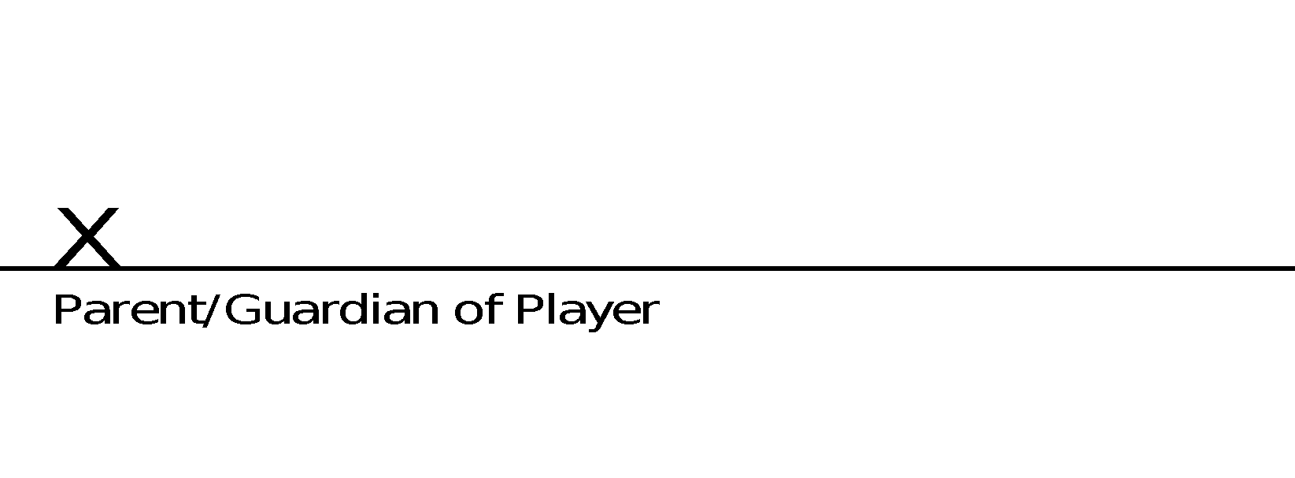

Signed this _____ day of _________(month) _______(year).

Please return this signed form to your coach by ____________________.

